# Comparing means

## **Notations**

|  |  |
| --- | --- |
| **Population statistics** | |
| Population mean | $$μ$$ |
| Population variance | $$σ^{2}=\sum_{i=1}^{N}{\frac{{\left(x_{i}-μ\right)}^{2}}{N}}$$ |
| Population standard deviation | $$σ= \sqrt{σ^{2}}=\sqrt{\sum_{i=1}^{N}{\frac{{\left(x_{i}-μ\right)}^{2}}{N}}}$$ |
| Standard error of a population mean | $$σ_{\overline{x}}=\frac{σ}{\sqrt{n}}$$ |
| **Sample statistics** | |
| Sample mean | $$\overline{x}=\frac{\sum_{i=1}^{n}{x_{i}}}{n}$$ |
| Sample variance | $$s^{2}=\sum_{i=1}^{n}{\frac{{\left(x_{i}-\overline{x}\right)}^{2}}{n-1}}$$ |
| Sample standard deviation | $$s= \sqrt{s^{2}}=\sqrt{\sum_{i=1}^{n}{\frac{{\left(X_{i}-X\right)}^{2}}{n-1}}}$$ |
| Standard error of the sample mean | $$s_{\overline{x}}=\frac{s}{\sqrt{n}}$$ |
| **Independent two samples** | |
| Mean of the difference between samples | $μ_{diff}=μ_{1}-μ_{2}$ or $$μ_{diff}=μ_{1}+μ_{2}$$ |
| Variance of the difference between samples | $$σ_{diff}^{2}=σ_{1}^{2}+σ_{2}^{2}$$ |
| Standard deviation of the difference between samples | $$σ_{diff}=\sqrt{σ_{1}^{2}+σ_{2}^{2}}$$ |
| Standard error of the difference between samples | $$SE_{diff}=\sqrt{\frac{σ_{1}^{2}}{n_{1}}+\frac{σ_{2}^{2}}{n_{2}}}$$ $$SE_{diff}=\sqrt{\frac{s_{1}^{2}}{n_{1}}+\frac{s_{2}^{2}}{n_{2}}}$$ |
| Distribution of the difference between two sample means | $$\sim Norm(μ_{diff}, σ_{diff})$$ |

## **Hypothesis testing**

|  |  |
| --- | --- |
| **Two independent samples t-test** | |
| Equal variances, Unequal sample sizes | |
| test statistic | $$t=\frac{\overline{x_{1}}-\overline{x_{2}}}{SE}$$ |
| pooled standard deviation | $$s_{p}^{2}=\frac{s_{1}^{2}\left(n_{1}-1\right)+s_{2}^{2}(n_{2}-1)}{{(n}_{1}-1)+(n_{2}-1)}$$ |
| Standard error | $SE=s_{p}*\sqrt{\frac{1}{n_{1}}+\frac{1}{n_{2}}}$ |
| degrees of freedom | $$df={(n}_{1}-1)+(n_{2}-1)$$ |
| Equal variances, Equal sample sizes | |
| test statistic | $$t=\frac{\overline{x_{1}}-\overline{x_{2}}}{SE}$$ |
| pooled standard deviation | $$s_{p}^{2}=\frac{s_{1}^{2}+s_{2}^{2}}{2}$$ |
| Standard error | $SE=s_{p}*\sqrt{\frac{2}{n}}$ |
| degrees of freedom | $$df=2*n-2$$ |
| Unequal variances (Welch’s test) | |
| test statistic | $$t=\frac{\overline{x_{1}}-\overline{x_{2}}}{SE}$$ |
| degrees of freedom | $$df={min⁡\{(n}_{1}-1),(n_{2}-1)\}$$ or Welch–Satterthwaite equation $$df=\frac{{\left(\frac{s_{1}^{2}}{n_{1}}+\frac{s_{2}^{2}}{n_{2}}\right)}^{2}}{\frac{{\left(s_{1}^{2}/n_{1}\right)}^{2}}{n_{1}-1}+\frac{{\left(s_{2}^{2}/n_{2}\right)}^{2}}{n_{2}-1}}$$ |
| Standard error | $SE=\sqrt{\frac{s_{1}^{2}}{n_{1}}+\frac{s_{2}^{2}}{n_{2}}}=\sqrt{SE_{1}^{2}+SE_{2}^{2}}$ |
| distribution of test statistic | $$t\sim t(df)$$ |
| **One sample t-test** | |
| test statistic | $$t=\frac{\overline{x}-μ_{0}}{SE}$$ |
| Standard error | $$SE=s_{\overline{x}}=\frac{σ}{\sqrt{n}}=\frac{s}{\sqrt{n}}$$ |
| degrees of freedom | $$df=n_{1}-1$$ |
| distribution of test statistic | $$\sim Norm(0,1)$$ |

## **Sample size calculation**

|  |  |
| --- | --- |
| **Two samples** | |
| Effect size | $$δ=µ_{0}-µ_{1}$$ |
| Critical value condition | $$0+z_{α/2}*SE=δ-z_{β}*SE$$ |
| Equal variances, Equal sample sizes | |
| Critical value condition | $$0+z_{α/2}*σ\sqrt{\frac{2}{n}}=δ-z_{β}*σ\sqrt{\frac{2}{n}}$$ |
| Minimum sample size | $$n=\frac{2{\left(z_{α/2}+z_{β}\right)}^{2}*σ^{2}}{δ^{2}}$$ Multiplier   |  |  |  |  | | --- | --- | --- | --- | | / |  |  |  | | 0.8 | 11.7 | 7.9 | 6.2 | | 0.9 | 14.9 | 10.5 | 8.6 | | 0.95 | 17.8 | 13.0 | 10.8 |   So for $α=0.05$ and $β=0.2$, $m ≈ 7.9$, $2*m ≈ 15.8$ |
| Rule of thumb | $$n=\frac{16}{∆^{2}}=16*\frac{σ^{2}}{δ^{2}}$$ $∆ =\frac{δ}{σ} =\frac{µ_{0}-µ_{1}}{σ}$ shows the number of standard deviations the means are away from each other. 16 is the numerator.  When   |  |  |  |  | | --- | --- | --- | --- | |  | Power |  | | | One sample | Two sample | | 0.5 | 0.5 | 4 | 8 | | 0.2 | 0.8 | 8 | 16 | | 0.1 | 0.9 | 11 | 21 | | 0.05 | 0.95 | 13 | 26 | | 0.025 | 0.975 | 16 | 31 | |
| Detectable difference | $${δ=µ}_{0}-µ_{1}=\frac{4*σ}{\sqrt{n}}$$ |
| Equal variances, Unequal sample sizes | |
| Minimum sample size | $$n_{1}=r*n_{2}$$ $$n_{2}=\frac{{\left(z_{α/2}+z_{β}\right)}^{2}σ^{2}(1+1/r)}{δ^{2}}$$ |
| Unequal variances, Unequal sample sizes | |
| Critical value condition | $$0+z_{α/2}*σ_{0}\sqrt{\frac{1}{n_{0}}+\frac{1}{n_{1}}}=δ-z_{β}*\sqrt{\frac{σ_{0}^{2}}{n_{0}}+\frac{σ_{1}^{2}}{n_{1}}}$$ |
| Minimum sample size | $$n=\frac{{\left(z_{α/2}+z_{β}\right)}^{2}*{(σ}_{1}^{2}+σ_{2}^{2})}{δ^{2}}$$ |
| **One sample** | |
| Effect size | $$δ=\overline{x}-μ_{0}$$ |
| Critical value condition | $$\frac{\overline{x}-μ_{0}}{\frac{s}{\sqrt{n}}}-z_{α/2}=z_{β}$$ |
| Minimum sample size | $$n=\frac{{\left(z_{α/2}+z_{β}\right)}^{2}*σ^{2}}{δ^{2}}$$ |

# Comparing proportions

## **Notations**

|  |  |  |  |
| --- | --- | --- | --- |
| **Group** | **Success** | **Failure** | **Total** |
| *Control (group 1)* | $$a$$ | $$c$$ | $$n_{1}$$ |
| *Treatment (group 2)* | $$b$$ | $$d$$ | $$n_{2}$$ |
| *Total* | $$s$$ | $$f$$ | $$N$$ |

$${\hat{p}}_{1}=\frac{a}{n_{1}}, {\hat{p}}_{2}=\frac{b}{n_{2}}$$

## **Hypothesis testing**

|  |  |
| --- | --- |
| **Two samples** | |
| Z Test (or Chi-Square Test) | |
| test statistic | $$z_{t}=\frac{{\hat{p}}_{1}-{\hat{p}}_{2}}{SE}$$ |
| Standard error (**unpooled version**) | $$SE=\sqrt{\frac{s_{1}^{2}}{n_{1}}+\frac{s_{2}^{2}}{n_{2}}}$$ where $$s_{1}^{2}={\hat{p}}_{1}*\left(1-{\hat{p}}_{1}\right)$$ $$s_{2}^{2}={\hat{p}}_{2}*\left(1-{\hat{p}}_{2}\right)$$ |
| Standard error (**pooled version**)  Satterthwaite approximation for pooled standard error | $$SE=\sqrt{s_{p}*\left(\frac{1}{n_{1}}+\frac{1}{n_{2}}\right)}=\sqrt{{\hat{p}}_{p}(1-{\hat{p}}_{p})\left(\frac{1}{n_{1}}+\frac{1}{n_{2}}\right)}$$ where $${\hat{p}}_{p}=\frac{p_{1}*n_{1}+p_{2}*n_{2}}{n_{1}+n_{2}}=\frac{a+b}{n_{1}+n_{2}}$$ |
| distribution of test statistic | $$z_{t}\sim Norm(0,SE)$$ |
| T-Test | |
| test statistic | $$t=(ad-bc)\left(\frac{N-2}{N*(n_{1}ac-n_{2}bd)}\right)$$ |
| Degrees of freedom | $$df=N-2$$ |
| distribution of test statistic | $$t\sim t(df=N-2)$$ |
| **One sample** | |
| test statistic | $$z_{t}=\frac{\hat{p}-{\hat{p}}_{0}}{SE}$$ |
| Standard error | $$SE=\sqrt{\frac{\hat{p}(1-\hat{p})}{n}}$$ |

## **Sample size calculation**

|  |  |
| --- | --- |
| **Two samples** | |
| Unequal variances, Unequal sample sizes | |
| Minimum sample size | $$n_{1}=r*n_{2}$$ $$n_{2}=\frac{{\left(z_{α/2}+z_{β}\right)}^{2}}{δ^{2}}*\left[\frac{p_{1}(1-p_{1})}{r}+p_{2}(1-p_{2})\right]$$ |
| Unequal variances, Equal sample sizes | |
| Minimum sample size | $$n_{1}=n_{2}=\frac{{\left(z_{α/2}+z_{β}\right)}^{2}\left(p_{1}(1-p_{1})+p_{2}(1-p_{2})\right)}{δ^{2}}$$ |
| **One sample** | |
| Critical value condition | $$0+z_{α/2}*SE=δ-z_{β}*SE$$ |
| Minimum sample size | $$n=\frac{{\left(z_{α/2}+z_{β}\right)}^{2}*p(1-p)}{δ^{2}}$$ |

# Graphs

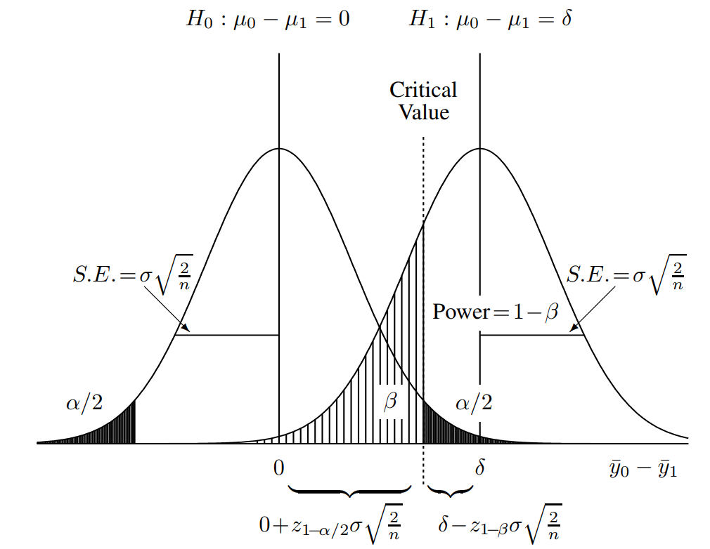

# Table of t values

|  |  |  |  |
| --- | --- | --- | --- |
| $$α$$ | Confidence | $$Z_{α}$$ | $$Z_{\frac{α}{2}}$$ |
| 0.0005 | 99.9% | 3.291 |  |
| 0.001 | 99.8% | 3.090 | 3.291 |
| 0.005 | 99% | 2.576 | 3.090 |
| 0.01 | 98% | 2.326 | 2.576 |
| 0.025 | 95% | 1.960 | 2.326 |
| 0.05 | 92% | 1.645 | 1.960 |
| 0.1 | 80% | 1.282 | 1.645 |
| 0.15 | 70% | 1.036 | 1.282 |
| 0.2 | 60% | 0.842 | 1.036 |
| 0.25 | 50% | 0.674 | 0.842 |